

ATAR CHEMISTRY UNITS 1 AND 2

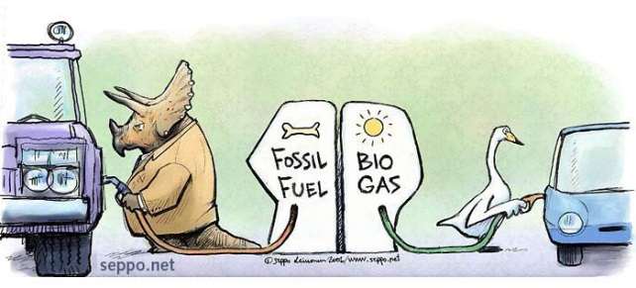**Extended Response: Fossil Fuels and Biofuels**

**Weighting: 5%**

**Validation Test Date:**

**Task:** This task is divided into three parts (Leinonen nd)

1. Complete the following research questions.
2. Complete the table below on the fossil fuels and biofuels given. For fuels that are a mixture, give the most common component or a typical component of the fuel.

|  |  |  |  |
| --- | --- | --- | --- |
| **Fuel** | **Main Component Name/Formula** | **Energy Output**  **(kJ g-1)** | **Energy Output**  **(kJ mol-1)** |
| Coal |  | 29 |  |
| Petroleum |  | 43 |  |
| Petrodiesel |  | 43 |  |
| Natural gas |  | 45 |  |
| Biodiesel |  | 38 |  |
| Bioethanol | Ethanol / C2H5OH | 27 |  |

1. Determine the amount of carbon dioxide produced in grams for every MJ of heat released **(g(CO2­)MJ-1)** in the complete combustion of each of the fuels given in the table. You must show full working.
2. Using the values from Q2, decide which is the most and which is the least environmentally friendly fuel.
3. Comment on the assumption that during a combustion reaction a fuel is reacted with oxygen to produce carbon dioxide and water vapour only. What other products may be produced. Give reasons for your answer.
4. Give correctly referenced sources you have used to get information (you must use at least two sources).
5. Complete **Set 22 Q10-14a).**  Use 13.8-13.10 from *Essential Chemistry* as a reference.

1. You will be tested on this work in class under strict test conditions.

Bibliography

Leinonen, Seppo. “Fossil Fuel - Biogas.” *Sepponet Environmental Cartoons.* nd. http://www.seppo.net/cartoons/displayimage.php?pid=736 (accessed May 13, 2015).

1. You will need to read pages 103 (13.8 Fuels: The Energy Source for a Modern Economy) – 107 in *Essential Chemistry Australian Chemistry for Western Australia: ATAR Chemistry Units 1 + 2 (Lucarelli)* and then complete **Set 22 questions 10 – 14** **(pages 110 – 111)**.
2. You will be tested on a selection of these questions in class under strict test conditions.

# Bibliography

Biomass Energy Centre. “Carbon Emissions of Different Fuels.” *Biomass Energy Centre.* 2012. http://www.biomassenergycentre.org.uk/portal/page?_pageid=75,163182&_dad=portal&_schema=PORTAL (accessed May 25, 2015).

Blake. “Mrs Blake's Chemistry.” *Anoka-Hennepin Schools.* n.d. http://moodle.anoka.k12.mn.us/course/view.php?id=606&section=2 (accessed January 30, 2015).

Leinonen, Seppo. “Fossil Fuel - Biogas.” *Sepponet Environmental Cartoons.* nd. http://www.seppo.net/cartoons/displayimage.php?pid=736 (accessed May 13, 2015).

The Engineering Toolbox. “Combustion Fuels - Carbon Dioxide Emissions.” *The Engineering Toolbox.* nd. http://www.engineeringtoolbox.com/co2-emission-fuels-d_1085.html (accessed May 25, 2015).

Wikimedia. “Energy Content of Biofuel.” *Wikipedia.* 2015. http://en.wikipedia.org/wiki/Energy_content_of_biofuel (accessed May 25, 2015).

Woodford, Chris. “Car Engines.” *Explain That Stuff.* 20 March 2015. http://www.explainthatstuff.com/carengines.html (accessed May 25, 2015).